**EXPERIMENT 6.1**

**TITLE :** Demonstrate networking in python - TCP file download.

**server.py**

*#server program*

*import socket*

*host='localhost'*

*port=5000*

*s=socket.socket(socket.AF_INET,socket.SOCK_STREAM)*

*s.bind((host,port))*

*s.listen(1)*

*c,addr=s.accept()*

*print("Connection from: ",str(addr))*

*#c.send(b"Hello client, how r u")*

*f=open("new.txt","r")*

*str1=f.read()*

*c.send(str.encode(str1))*

*msg="Bye!"*

*c.send(msg.encode())*

*c.close()*

**client.py**

*#client program*

*import socket*

*host='localhost'*

*port=5000*

*s=socket.socket(socket.AF_INET,socket.SOCK_STREAM)*

*s.connect((host,port))*

*msg=s.recv(1024)*

*while msg:*

*print('Received : '+msg.decode())*

*msg=s.recv(1024)*

*s.close()*

**New.txt**

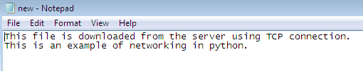

**Output :**

